Instruction to convert foreign currency and make payments to Sri Lanka

**Through the website**

1. Open the website **www.nipbank.ru**
2. Open the tab Банк-клиент + СБП (Client Bank + SBP)

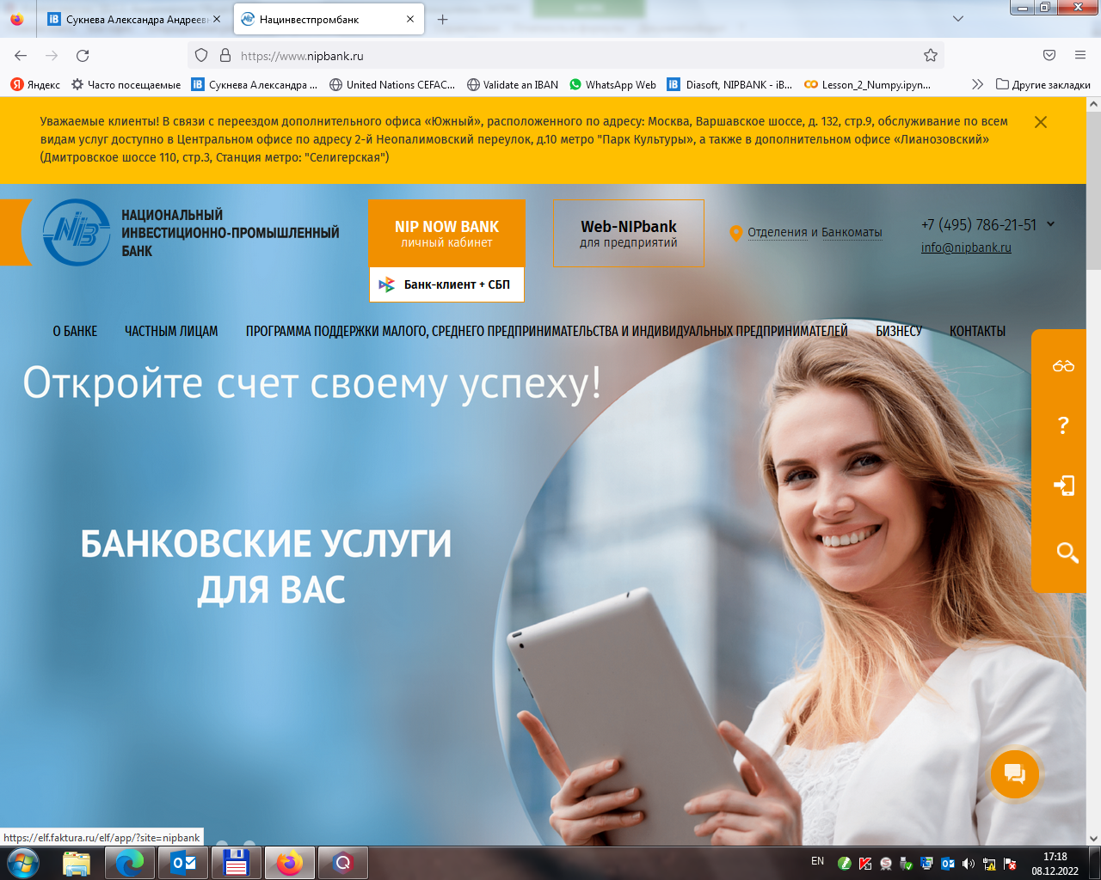

1. Enter login and password

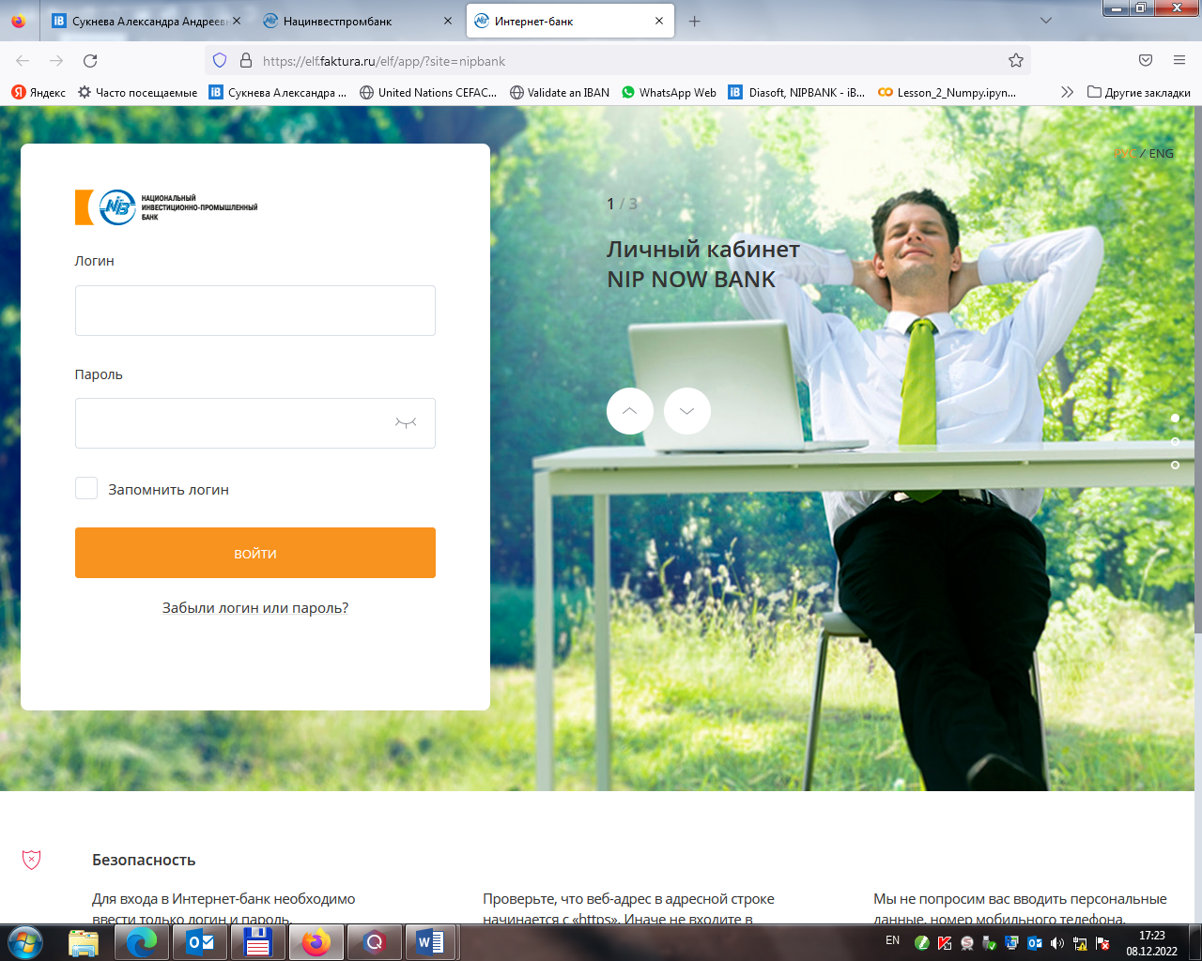

1. An SMS with a confirmation code will be sent to the number specified during registration, which will need to be entered in the field below

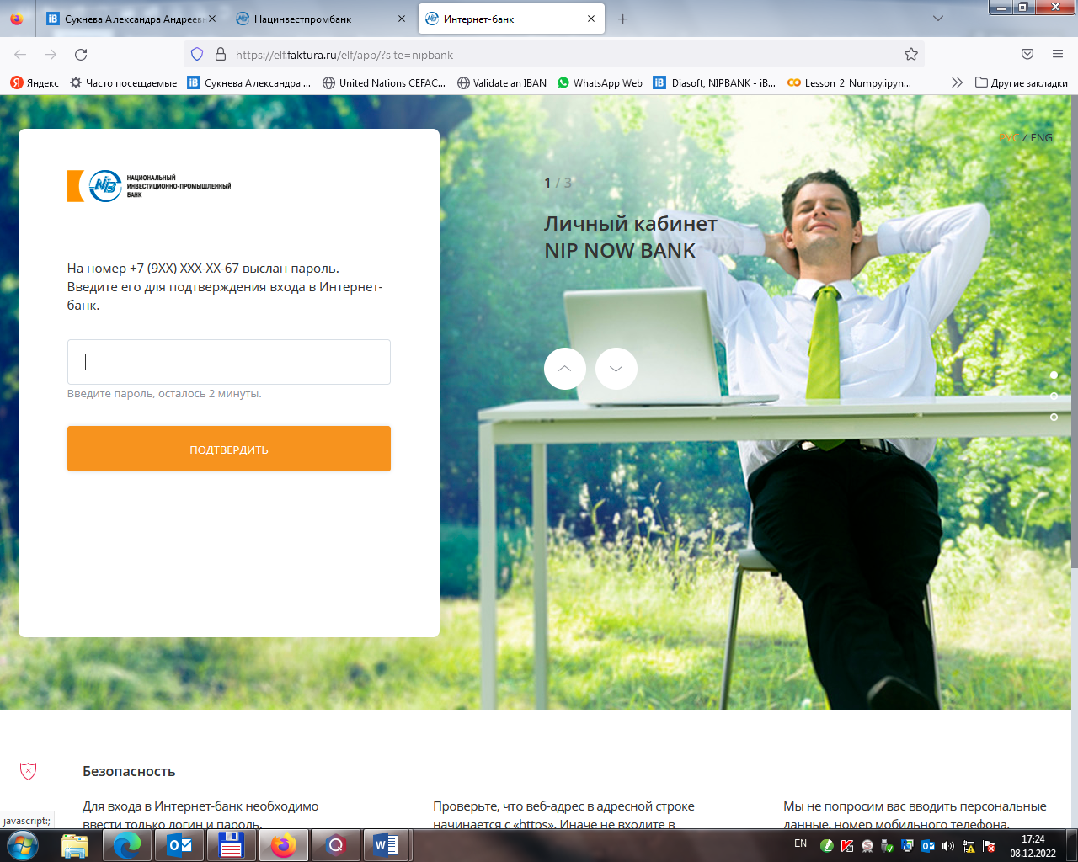

1. To convert foreign currency choose a tab ПЛАТЕЖИ И ПЕРЕВОДЫ (PAYMENTS AND TRANSFERS), then choose Обмен валют (Currency exchange)

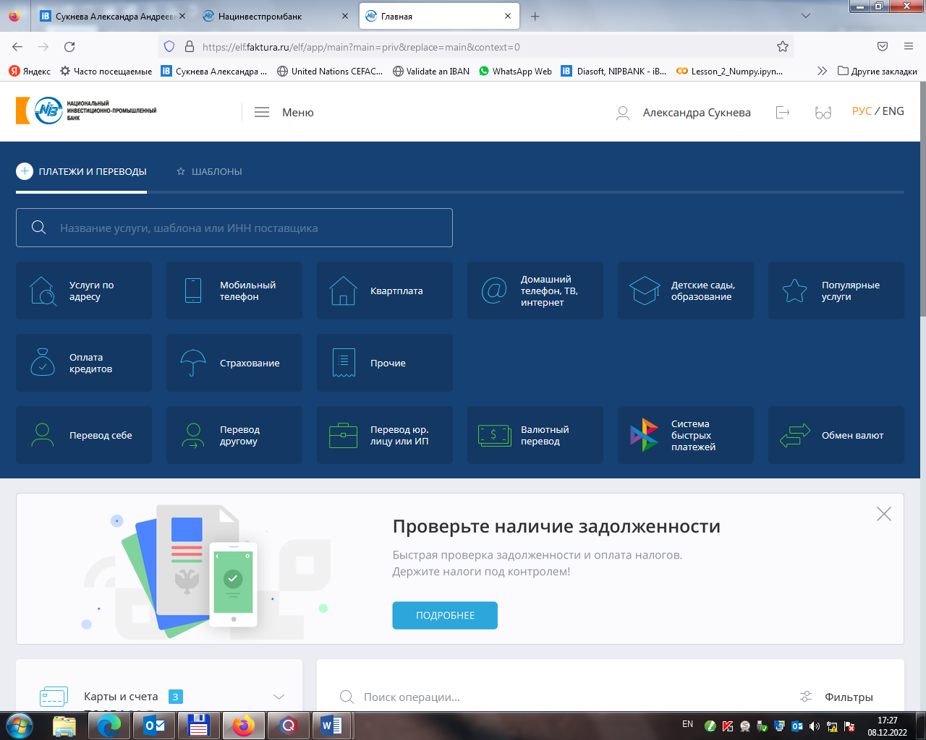

1. Select an account for debiting (ruble) and crediting (in USD), specify the amount in USD or rubles. Click TRANATE. The exchange rate is indicated below.

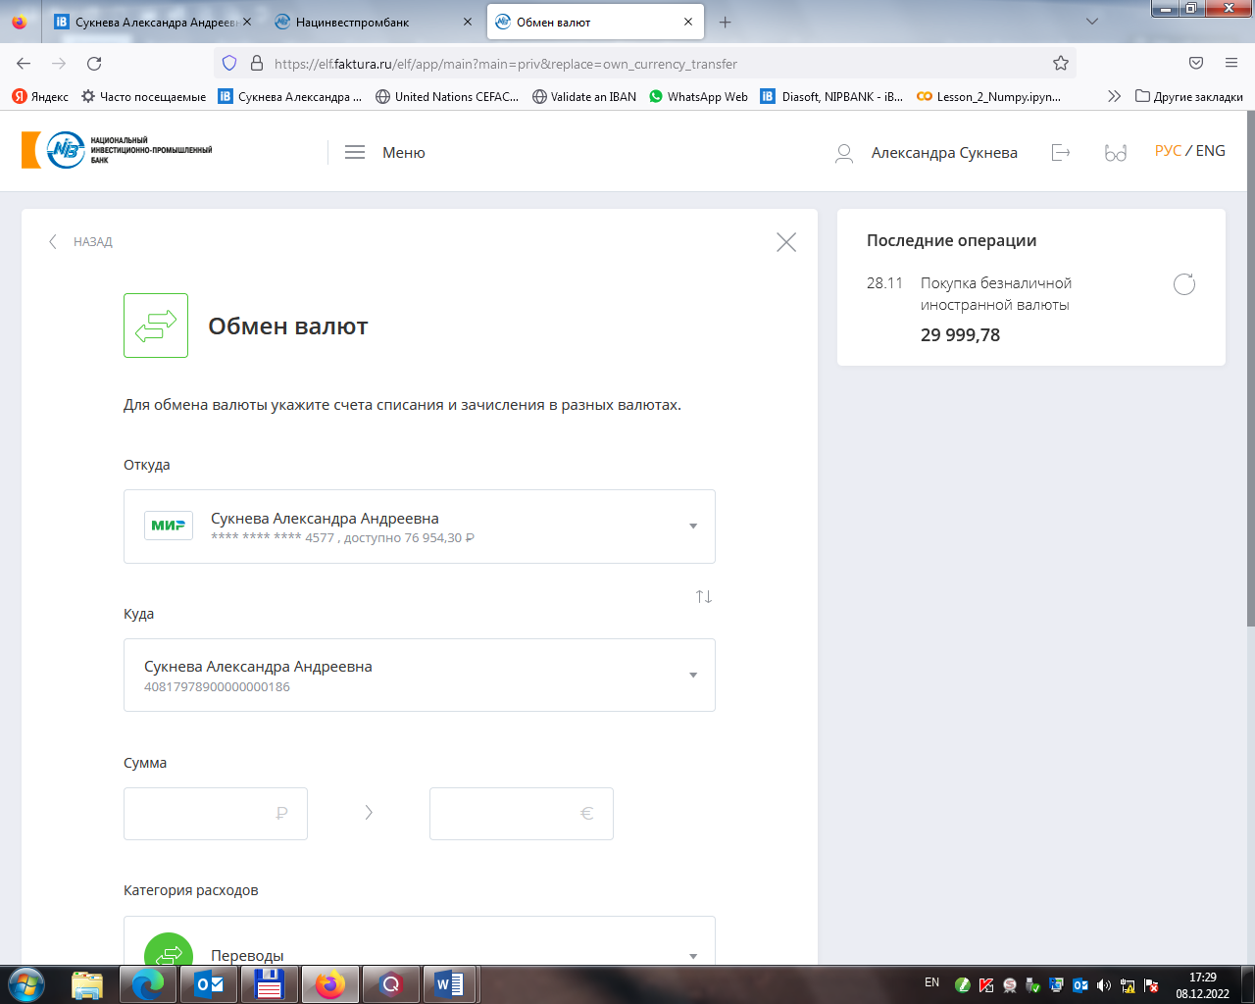

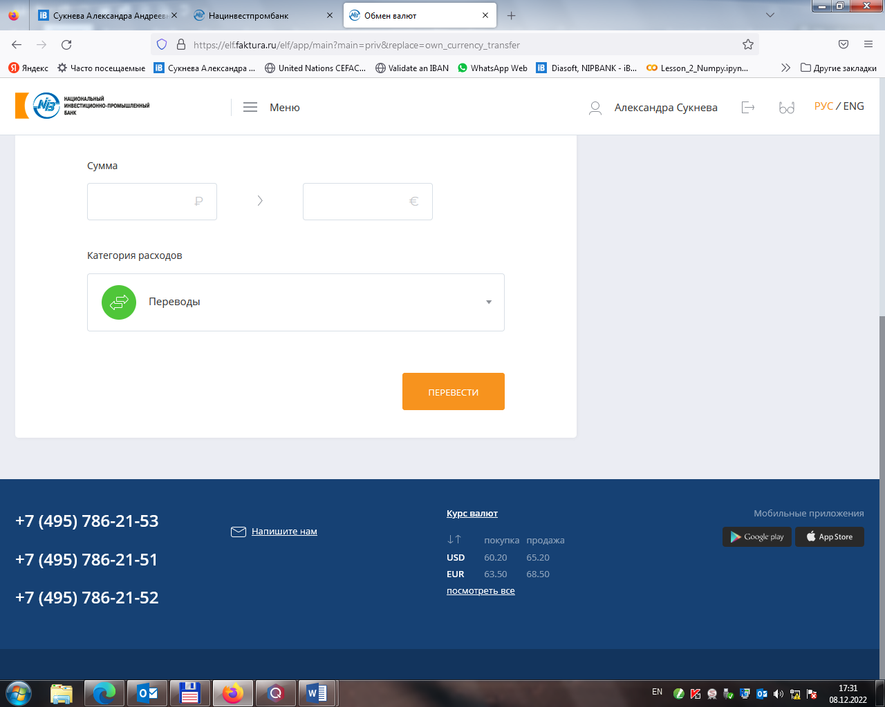

1. To send a payment to Sri Lanka, select ПЛАТЕЖИ И ПЕРЕВОДЫ (PAYMENTS AND TRANSFERS) tab, then Валютный перевод (Currency transfer).

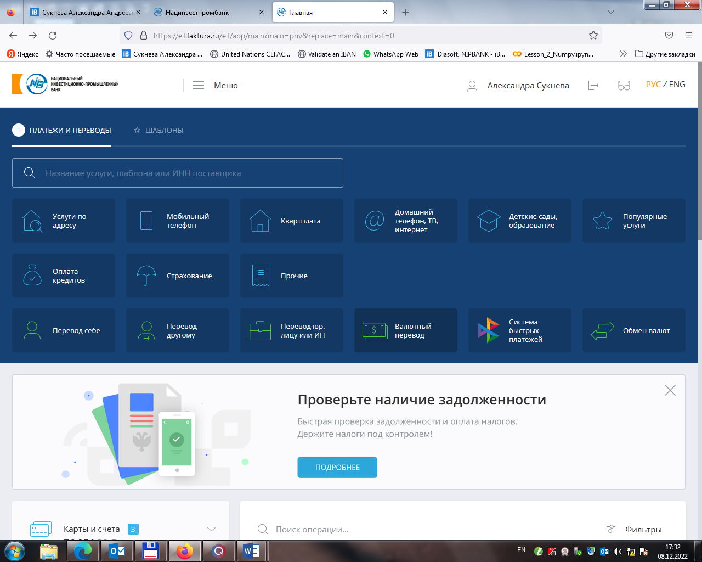

1. 8. Fill in the details for the transfer (SAMPLE:

* Payer (Плательщик): first and last name in English (IVAN IVANOV)
* Debit account (Счет списания): account in dollars
* Payer's address in English (Адрес плательщика) - (Country: RUSSIAN FEDERATION, City: MOSCOW, Street, house, apartment: PETROVKA STREET, 20, AP. 10)
* Recipient (Получатель): first and last name in English (IVAN IVANOV)
* Recipient's account (Счет получателя): account opened in People's Bank
* Recipient's address in English (Адрес получателя) - (Country: RUSSIAN FEDERATION, City: MOSCOW, Street, house, apartment: PETROVKA STREET, 20, AP. 10)
* SWIFT/BIC of the bank: PSBKLKLX
* Bank: PEOPLE'S BANK,HEAD OFFICE, HEAD OFFICE
* Purpose of payment (Назначение платежа): TRANSFER OF OWN FUNDS
* Transfer costs are borne by (Расходы за перевод несет): Payer (Плательщик)
* Account to debit charges (Счет для списания расходов): account in USD
* Amount of transfer in dollars (Сумма перевода)
* At the end, you can save the payment as a template for future use (Сохранить платеж как шаблон)

